 

[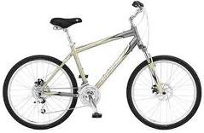](http://www.google.com/imgres?imgurl=http://www.cpsc.gov/cpscpub/prerel/prhtml05/05592b.jpg&imgrefurl=http://www.cpsc.gov/cpscpub/prerel/prhtml05/05592.html&usg=__OG8K9pZ7j4XRFWH3Mqs_w9KasSY=&h=311&w=476&sz=32&hl=en&start=38&sig2=g_R8bUsMFpJtycCEn8urwg&zoom=1&tbnid=VcfJgginhGcRhM:&tbnh=110&tbnw=168&ei=ft81TbHpHoHZgQfM0-iWCw&prev=/images%3Fq%3Dbicycle%26hl%3Den%26safe%3Dactive%26biw%3D1020%26bih%3D562%26gbv%3D2%26tbs%3Disch:1&itbs=1&iact=rc&dur=339&oei=c981TZXiB8rUgQfExMGwCw&esq=4&page=4&ndsp=15&ved=1t:429,r:8,s:38&tx=89&ty=58) 

[](http://www.google.com/imgres?imgurl=http://autodesk.blogs.com/photos/daily_grind_iii/img_5756.jpg&imgrefurl=http://autodesk.blogs.com/photos/daily_grind_iii/img_5756.html&usg=__u1cCLayQyNrOE-zzcGNysyGaScw=&h=426&w=640&sz=283&hl=en&start=41&sig2=_X2c02vuvxRfAkFwd9V-dA&zoom=1&tbnid=NgPOFmFk1E1MPM:&tbnh=123&tbnw=147&ei=AeA1TZbsCYXVgQfW7smlCw&prev=/images%3Fq%3Dblack%2Blab%26hl%3Den%26safe%3Dactive%26biw%3D1020%26bih%3D562%26gbv%3D2%26tbs%3Disch:1&itbs=1&iact=rc&dur=167&oei=-t81TeuqAcqtgQeUkcWjCw&esq=4&page=4&ndsp=17&ved=1t:429,r:6,s:41&tx=27&ty=36) [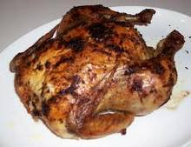](http://www.google.com/imgres?imgurl=http://upload.wikimedia.org/wikipedia/commons/a/a5/Roast_chicken.jpg&imgrefurl=http://commons.wikimedia.org/wiki/File:Roast_chicken.jpg&usg=___d9Xlgr1Pys2yfZdOfjazOhGQyw=&h=368&w=480&sz=39&hl=en&start=10&sig2=Wxy72mEaSIrqIbWUWbDI6A&zoom=1&tbnid=nLyJYzqk9qbY3M:&tbnh=123&tbnw=159&ei=LuA1Tf29NIXTgQePrPSZCw&prev=/images%3Fq%3Dchicken%26hl%3Den%26safe%3Dactive%26biw%3D1020%26bih%3D562%26gbv%3D2%26tbs%3Disch:1&itbs=1&iact=rc&dur=183&oei=LOA1TePmA5LpgAeQgomlCw&esq=2&page=2&ndsp=18&ved=1t:429,r:15,s:10&tx=93&ty=72)

[](http://www.google.com/imgres?imgurl=http://www.recipetips.com/kitchen/images/refimages/bread/types/Italian_bread_500.jpg&imgrefurl=http://www.recipetips.com/kitchen-tips/t--1124/basic-breads.asp&usg=__TDjkJbm5woH-BiI2j9BckQpaQuc=&h=302&w=500&sz=17&hl=en&start=23&sig2=Wo8LNYF6ZfFGuajIxwisAw&zoom=1&tbnid=0vOthjruaFsswM:&tbnh=100&tbnw=165&ei=S-A1TaSzPIi_gQfmh-SCCw&prev=/images%3Fq%3Dbread%26hl%3Den%26safe%3Dactive%26biw%3D1020%26bih%3D562%26gbv%3D2%26tbs%3Disch:1&itbs=1&iact=rc&dur=216&oei=ROA1TaXcLMXpgQeV_dWtCw&esq=3&page=3&ndsp=15&ved=1t:429,r:4,s:23&tx=52&ty=13) 

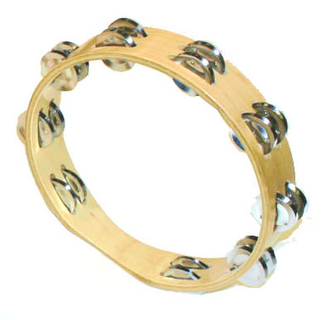 

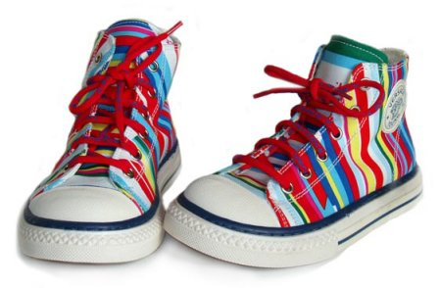 [](http://www.google.com/imgres?imgurl=http://turbo.indyposted.com/wp-content/uploads/2010/12/Glass-of-Milk.jpg&imgrefurl=http://www.indyposted.com/145052/top-10-ways-to-treat-heartburn-at-home/&usg=__NpyeqkxZ0o3fwcTCTZTjwjKSxL8=&h=318&w=300&sz=7&hl=en&start=0&sig2=01cfJKn0QwbtkbZ7xME1hg&zoom=1&tbnid=cQoAZr6q9Bc60M:&tbnh=161&tbnw=150&ei=weA1Te7INtH1gAegr8zMCw&prev=/images%3Fq%3Dmilk%26hl%3Den%26safe%3Dactive%26biw%3D1020%26bih%3D562%26gbv%3D2%26tbs%3Disch:1&itbs=1&iact=hc&vpx=374&vpy=187&dur=42&hovh=231&hovw=218&tx=111&ty=118&oei=uuA1Td2xHZH4gAfAzsC2Cw&esq=3&page=1&ndsp=11&ved=1t:429,r:2,s:0)